Project Design Phase-II
Data Flow Diagram & User Stories

Date | 27 December 2025
Team ID | 4967
Project Name | Bookstore
Maximum Marks | 4 Marks

Data Flow Diagrams:
A Data Flow Diagram (DFD) illustrates how data moves within the Indian Bookstore platform. It captures how users (book lovers and admin) interact with the system, how information flows between different components, and where the data is stored.
Example: DFD Level 0 (Industry Standard)

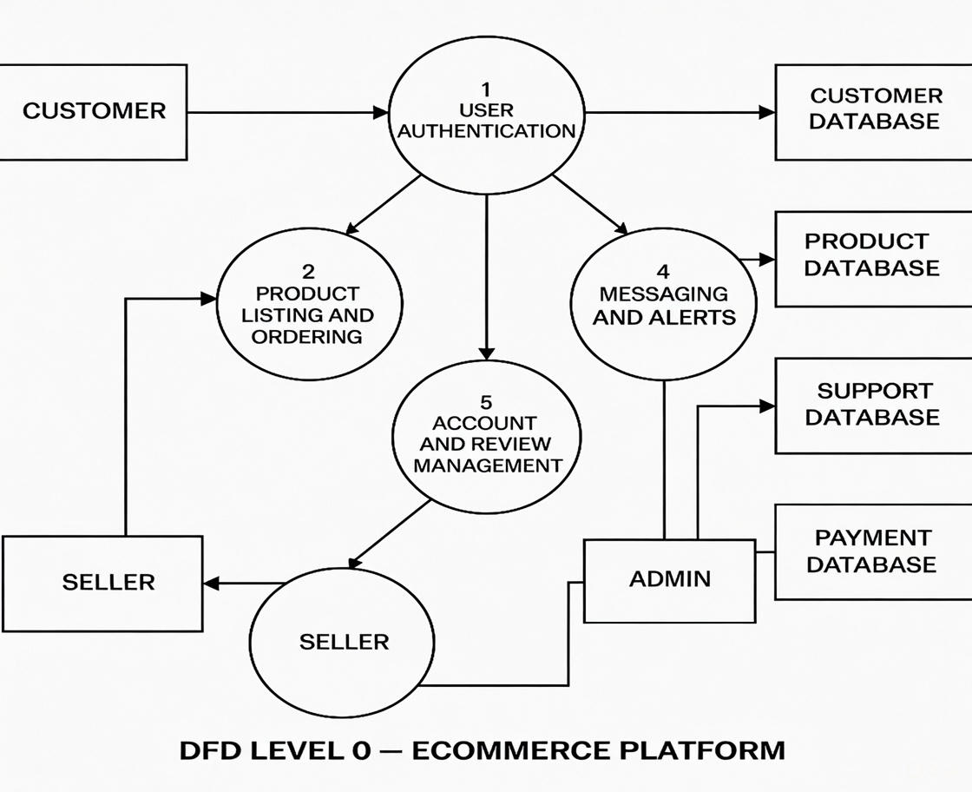

User Stories

User Story Table – Bookstore

User Type | Functional Requirement (Epic) | User Story / Task | Acceptance Criteria | Priority | Release
Visitor / User |  | As a visitor, I can browse all available books on the home page. | Books are displayed with title, author, price, and cover image. | High | Sprint-1
  Book Browsing
 |  | As a user, I can search books by title, author, or genre. | Relevant results appear with book count. | M  edium | Sprint-2
  Book Search
User | Book Details |  | Details include title, author, genre, price, description, and high-quality image | High | Sprint-1
  As a user, I can view detailed information about a book.
User | Shopping Cart | As a user, I can add books to my shopping cart. | Cart icon shows item count and items persist in cart page. | High | Sprint-2
User | Wishlist | As a user, I can add books to my wishlist. | Wishlist heart icon changes color and count updates. | High | Sprint-2
User | User Authentication | As a user, I can register and login to the platform. | Successful login shows "Hello" message and logout option. | High | Sprint-2
Admin | Book Management | As an admin, I can add, edit, or delete books. | Changes reflect immediately on the site. | High | Sprint-1
Admin | Admin Panel Access | As an admin, I can access the admin panel. | Reports and actions logged. | High | Sprint-1

